1.Install Maven

1.Send the screenshot of "mvn -version"

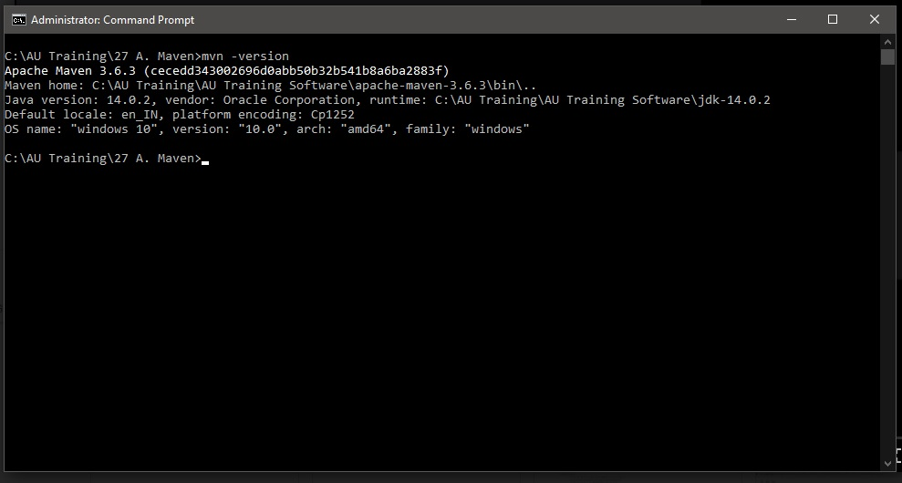

2.Create a sample maven project

1. Using archetype plugin and generate goal.

2. Give custom values for groupId, artifactId, version, package and execute "mvn install" and "mvn exec:java -Dexec.mainClass=your-fully-qualified-class-name".

3. Share zip of project and screenshot for "mvn install" and "mvn exec:java" command

Ans1. mvn archetype:generate -DgroupId=com.au.maven -DartifactId=maven-assignment -Dpackage=com.au.maven -Dversion=1.0 - DarchtypeArtifactId=maven-archtype-quickstart - DinteractiveMode=false

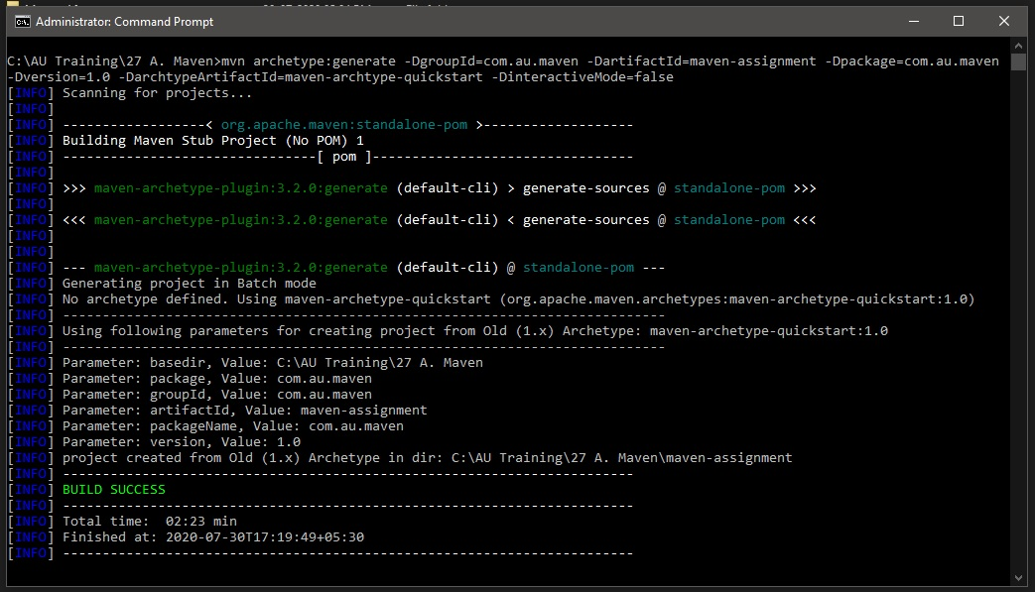

Ans2. mvn install

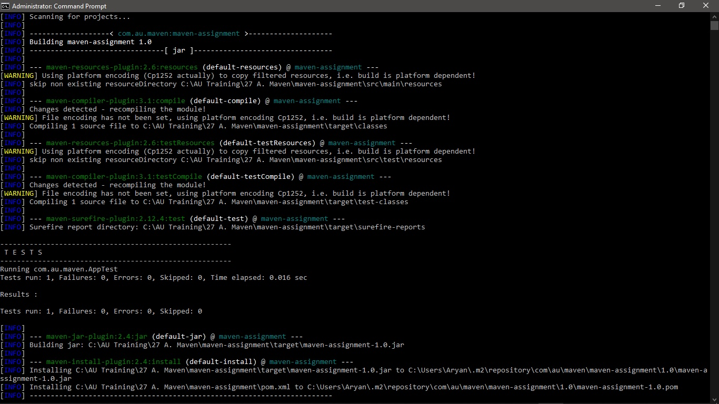

Ans3. mvn exec:java -Dexec.mainClass=com.au.maven.App

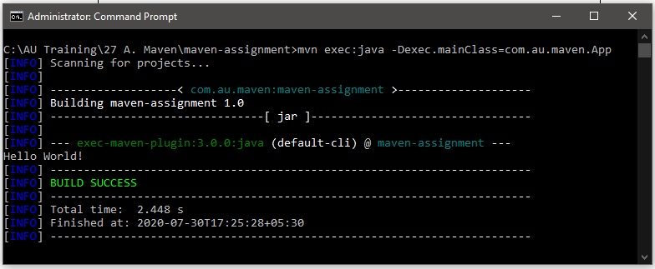

3.Create a maven web-app project

1. Using archetype plugin and generate goal.

2. Give custom values for groupId, artifactId, version, package and execute "mvn install" and "mvn exec:java -Dexec.mainClass=your-fully-qualified-class-name".

3. Share zip of project and screenshot for "mvn install"

Ans1. mvn archetype:generate -DgroupId=web.au.maven -DartifactId=maven-web -Dpackage=web.au.maven -Dversion=1.0 - DarchtypeArtifactId=maven-archtype-webapp -DinteractiveMode=false

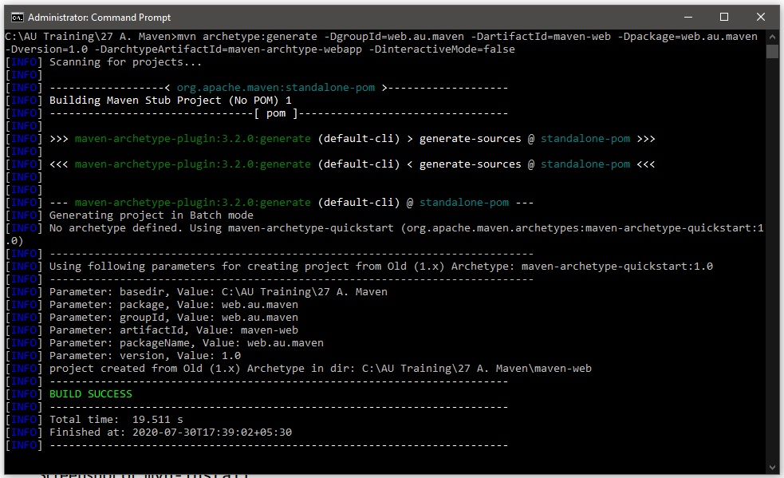

Ans2.

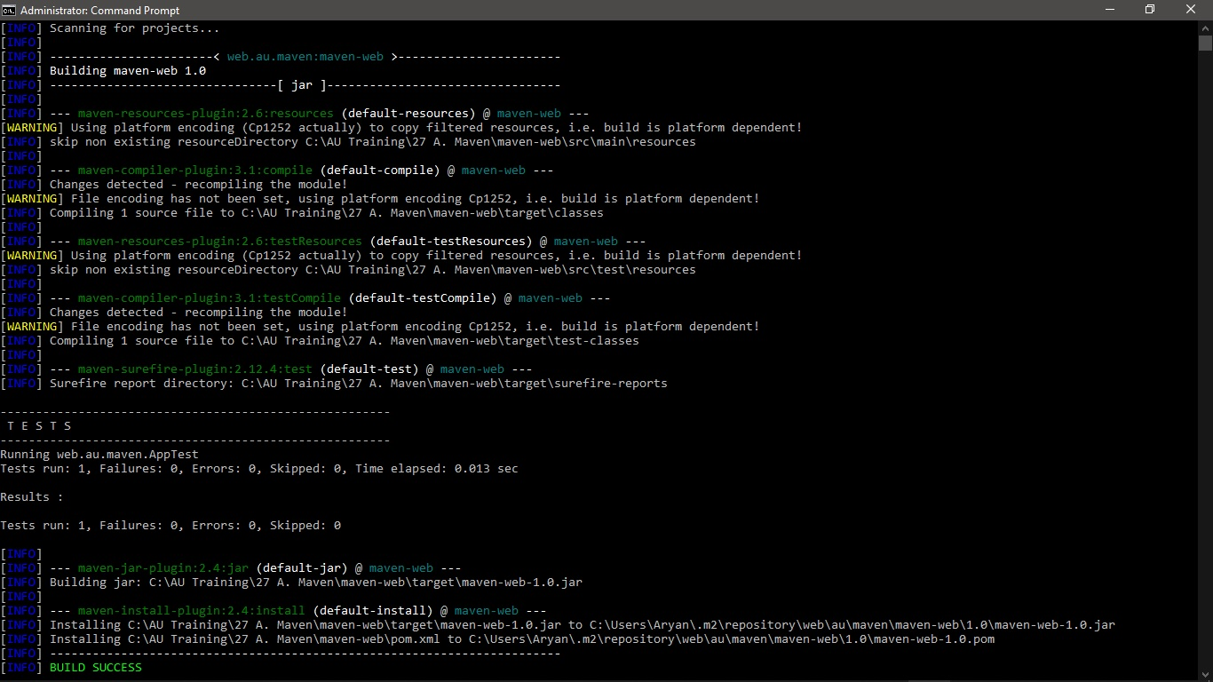

4.In the above created sample maven project (Step 2) run "mvn install" again but it should now skip the execution of tests.

1. Send the screenshot of "mvn install" that should skip the execution of tests.

Ans. 